Title

Subtitle

**Keywords:** Give at least five keywords separated by semicolons; do not end this part with a full stop

The abstract must contain a maximum of 500 words, including examples, figures, and tables, but excluding references, and should not exceed two pages. When preparing your abstract, it is recommended to use this template directly. Please do not insert blank lines between the different sections or paragraphs of your text. Use Calibri 11 with single line spacing for the main text and 14 for section titles. Please avoid hyphenation marks in the text. Your abstract must be submitted in an unlocked docx/odt format. The basic structure of each text consists of different sections: Title, optional Subtitle, Keywords, structured main text, and References. The abstracts must clearly outline the research questions, approach, method, data, and results. They must be anonymous: not only should they omit the names, affiliations, and addresses of the presenters, but they should also avoid any other information (e.g., in citations) that could reveal the identity of the author(s).

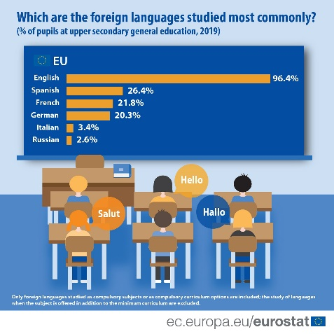

Fig. 1: Colour figures are allowed. Figures should be supplied in a clean and high-quality format, using, if possible, a resolution of a minimum of 300 dpi. Figures should be numbered consecutively

|  |  |
| --- | --- |
| ****Language**** | ****Number of L1-speakers (millions)**** |
| Spanish | 485 |
| English | 380 |
| French | 81 |

Table 1: Number the tables separately from the figures

Examples should be numbered consecutively, as shown in (1).

1. This is an example text.

Glossed examples should follow, as far as possible, the Leipzig Glossing Rules (Bickel, Comrie & Haspelmath, 2015), as exemplified in (2).

|  |  |  |  |  |  |  |
| --- | --- | --- | --- | --- | --- | --- |
| 1. Lezgian (Haspelmath, 1993: p. 207) | | | | | | |
|  | *Gila* | *abur-u-n* | *ferma* | *hamišaluǧ* | *güǧüna* | *amuq’-da-č.* |
|  | now | they-obl-gen | farm | forever | behind | stay-fut-neg |
|  | ‘Now their farm will not stay behind forever.’ | | | | | |

You can achieve the glossing and alignment by using a table and making the borders invisible or simply by copying example (2) and adjusting it to your needs. All bibliographical references used in the abstract should be listed in alphabetical order and in full detail at the end of the abstract in the references section. The following reference examples illustrate the basic format. For online sources, please state the date of access in brackets (last access: 8 February 2025), and please activate all hyperlinks.

# References

Bickel, B., Comrie, B. & Haspelmath, M. (2015). The Leipzig glossing rules: Conventions for interlinear morpheme-by-morpheme glosses. <https://www.eva.mpg.de/lingua/pdf/Glossing-Rules.pdf> (date de consultation : 18 mars 2023).

Ernst, P. (1994). *Meaning and Mind in Monkeys*. Master’s Thesis. Department of Philosophy, Kings College, University of London.

Greenbaum, S. (ed.) (1996). *Comparing English Worldwide: The International Corpus of English*. Oxford: Clarendon Press.

Haspelmath, M. (1993). *A grammar of Lezgian*. Mouton Grammar Library, 9. Berlin. In: New York [Preprint].

Hasselgård, H. & Johansson, S. (2011). Learner corpora and contrastive interlanguage analysis. In: Meunier, F., Paquot, M., Gilquin, G. & De Cock, S. (eds.), *A Taste for Corpora.* Amsterdam: Benjamins (Studies in Corpus Linguistics), pp. 33–61.

Soroli, E. (2024). How language influences spatial cognition, categorization of dynamic motion events and gaze behavior: a crosslinguistic comparison. *Language and Cognition*, 16(4): 924-968. DOI: [10.1017/langcog.2023.66](https://www.cambridge.org/core/journals/language-and-cognition/article/how-language-influences-spatial-thinking-categorization-of-motion-events-and-gaze-behavior-a-crosslinguistic-comparison/D5D6FCC7D91D98DD3D56AA3EB28F0BBE?utm_campaign=shareaholic&utm_medium=copy_link&utm_source=bookmark).

Teich, E. (2003). *Cross-Linguistic Variation in System and Text: A Methodology for the Investigation of Translations and Comparable Texts*. Berlin: Mouton de Gruyter.